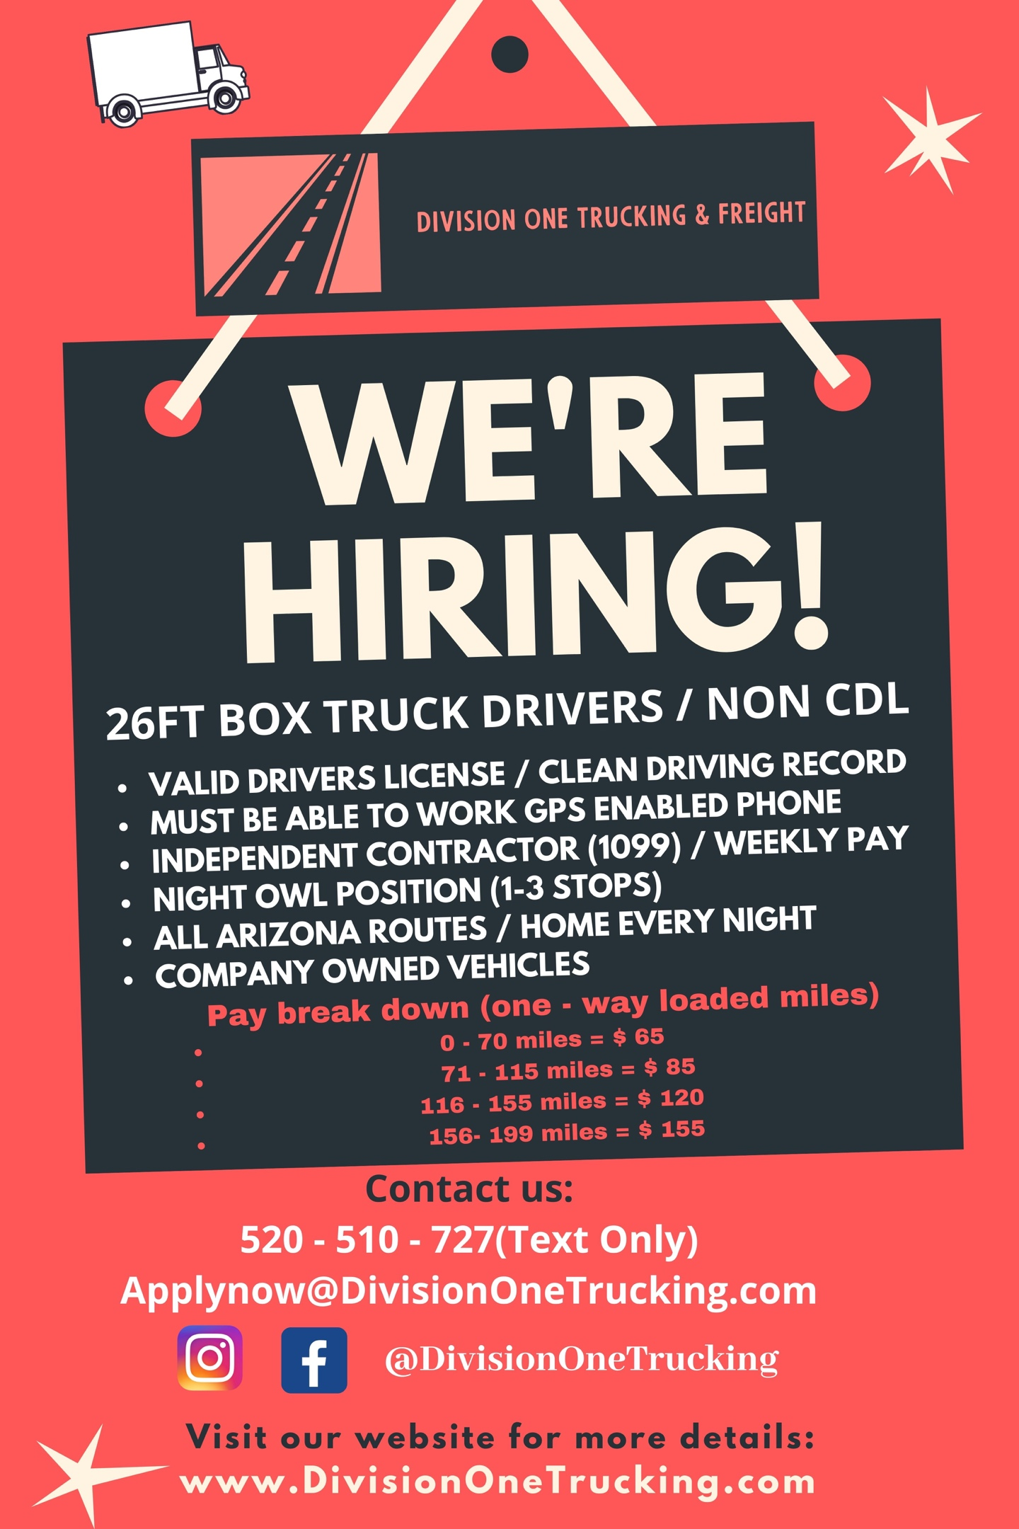

***26FT BOX TRUCK ( NON- CDL )***
Looking for entry level drivers to deliver loads in a 26ft company owned box trucks. All routes are in AZ. Must have valid drivers license and DOT medical card w CLEAN MVR (meaning no accidents or major moving violations within last 3 years). Please do not contact us if you don’t have a clean record.

Independent contractor!!! Pay weekly! Company owned vehicles! (1-3 stops on each route)

-Must have gps enabled smartphone that you can work easily without assistance
-Must be able to work in time sensitive manner
-Must be able to work independently
-Must load and unload using pallet jack
-Must have valid Arizona license

Pay scale:
No Touch Local / PHX : $50.00 ( Origin and delivery in PHX; not required to load / unload freight )
No Touch Tucson, AZ : $100.00 ( Origin and delivery in TUCSON; not required to load / unload freight )

Touch Routes: ( You are required to load these routes using a pallet jack )
Tucson Touch Routes: $120.00 ( Origin and delivery in TUCSON; required to load / unload freight )
0 – 70 miles: $65.00
71 – 115 miles: $85.00
116 – 155 miles: $120.00
156 – 199 miles : $155.00

Contact us only if you can dedicate Sunday through Thursday and are seriously interested in working. This is a Night owl position. Shift start times vary from 10pm, 12am and 1am, 2am, 3am, 4am, 5am. This position is located in West Phoenix. The ideal candidate is someone who lives in the West valley and has reliable transportation to and from work. Please don’t waste our time if you don’t match this description!

Business hours 9 am- 4pm MON – FRI (Manager will contact you if you interested)

